Name: ____________________________ Surname: ____________________________ N^{ber}: ____ Grade/Class: _____
Assessment: _____________________________ | Date: ___________________________________________________
 | Teacher’s signature:  ___________________________ | Parent’s signature:  ___________________________

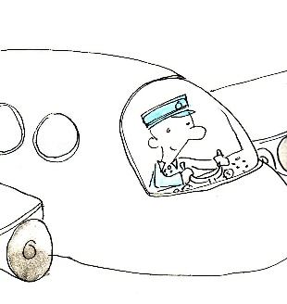
- Fill in the right words.

An ________________ is a person who is playing someone else.
A ________________ is a person who cooks food.
A ________________ is a person who delivers your mail.
A ________________ is a person who flies planes.
A ________________ is a person who educates children.
A ________________ is a person who takes care of sick animals.
A ________________ is a person who brings food and drinks to your table.
A ________________ is a person who puts out fires.
A ________________ is a person who takes care of sick people.
A ________________ is a person who grows vegetables.

- Complete the sentences.

theatre | farm | post office | hospital
vet clinic | school | airport | restaurant

If you want to buy fresh milk or vegetables, you can visit a ________________.
If you are feeling sick, you should go to the ________________.
If you want to see a play, you can go to the ________________.
When you are hungry, you can go to a ________________.
If your cat is sick, you should go to the ________________.
If you need to send a letter, you can buy a stamp at the ________________.
When you need to fly somewhere,you have to first go to the ________________.

