Name: ____________________________ Surname: ____________________________ N^{ber}: ____ Grade/Class: _____
Assessment: _____________________________ | Date: ___________________________________________________
 | Teacher’s signature:  ___________________________ | Parent’s signature:  ___________________________

What are their jobs? What do they do?

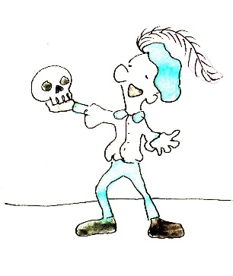
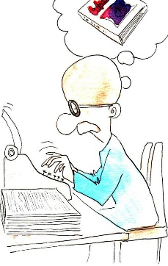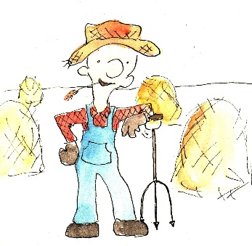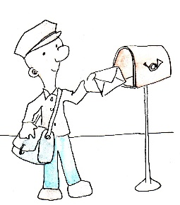
An actor acts _______________ _______________ _______________
The actor is acting _______________ _______________ _______________
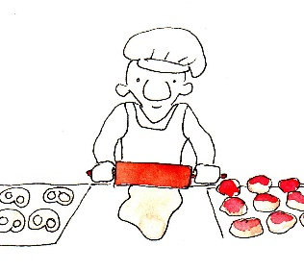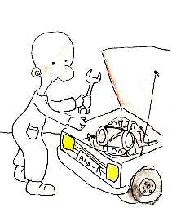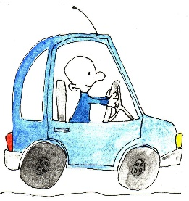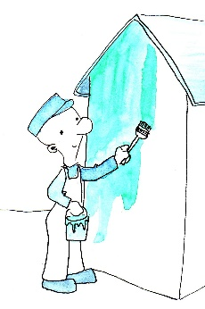
_______________ _______________ _______________ _______________
_______________ _______________ _______________ _______________

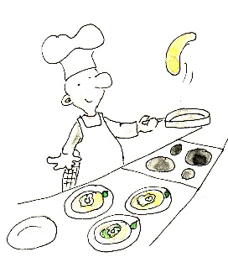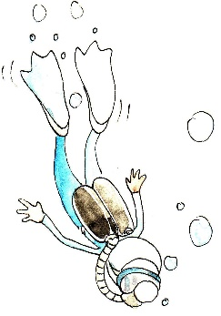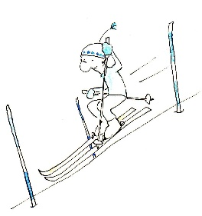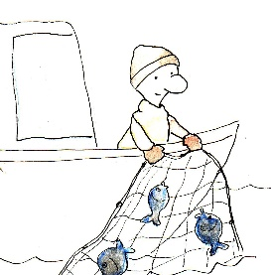
_______________ _______________ _______________ _______________
_______________ _______________ _______________ _______________

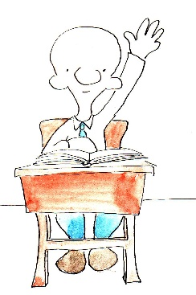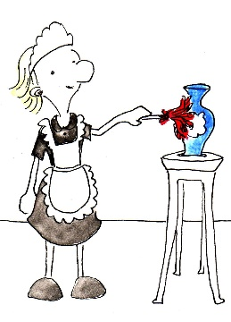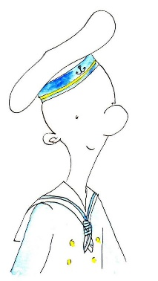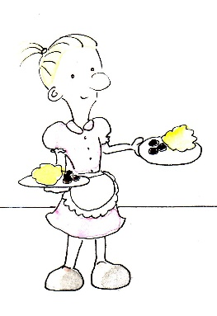
_______________ _______________ _______________ _______________
_______________ _______________ _______________ _______________

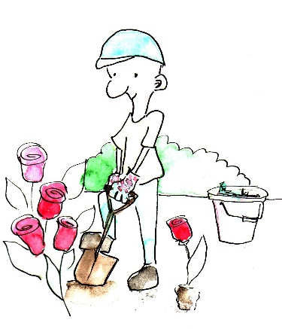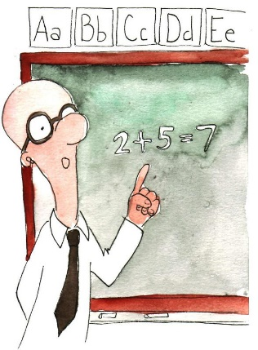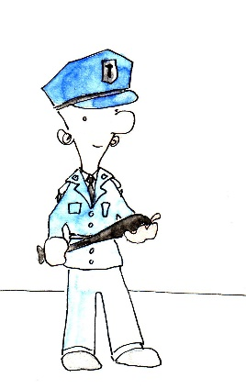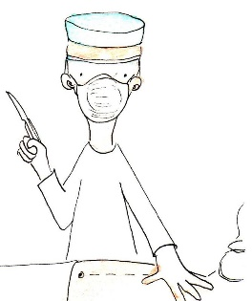
_______________ _______________ _______________ _______________
_______________ _______________ _______________ _______________

Key:
An actor /acts / is acting
A writer / an author/ writes / is writing
A farmer / farms / is farming
A mailman/postman / delivers mail / is delivering mail
A baker / bakes / is baking
A mechanic / repairs / is repairing
A driver/chauffeur / drives / is driving
A painter / paints / is painting
A chef / cook / cooks / is cooking
A diver / dives / is diving
A skier / skis / is skiing
A fisherman / fishes / is fishing
A student / learns /studies / is learning / is studying
A housekeeper/ cleaner / cleans / is cleaning
A sailor / sails / is sailing
A waitress waits / is waiting
A gardener / gardens / is gardening
A teacher / teaches / is teaching
A police officer / protects / is protecting
A surgeon / operates / is operating

