Name: ____________________________ Surname: ____________________________ N^{ber}: ____ Grade/Class: _____
Assessment: _____________________________ | Date: ___________________________________________________
 | Teacher’s signature:  ___________________________ | Parent’s signature:  ___________________________

Circle the correct job.

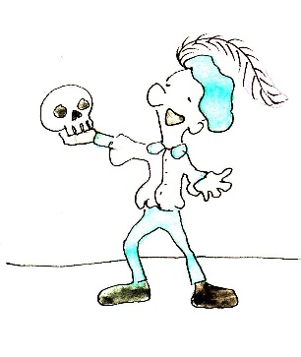
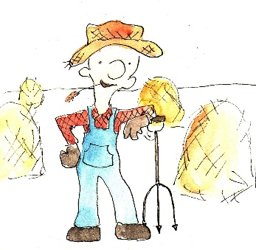
Actor Chef Baker Painter
Baker Writer Chef Mailman
Painter Fisherman Farmer Actor
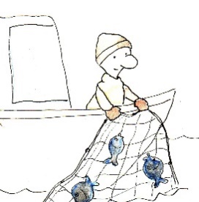
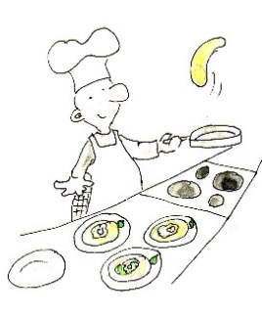
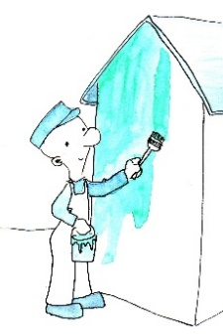
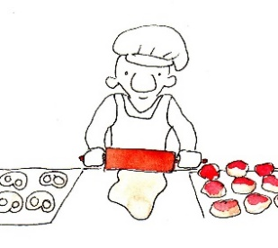

Farmer Painter Actor Fisherman
Writer Chef Baker Farmer
Baker Fisherman Chef Actor

