Name: ____________________________ Surname: ____________________________ N^{ber}: ____ Grade/Class: _____
Assessment: _____________________________ | Date: ___________________________________________________
 | Teacher’s signature:  ___________________________ | Parent’s signature:  ___________________________

Find and circle the jobs in the word search, and write them in the correct place.

- A _ _ _ _ _ _ _ _
2. A _ _ _ _
3. B _ _ _ _
4. B _ _ _ _ _
5. B _ _ _ _ _ _
6. C _ _ _
7. D _ _ _ _ _
8. D _ _ _ _ _
9. F _ _ _ _ _
10. L _ _ _ _ _
11. N _ _ _ _
12. P _ _ _ _
13. P _ _ _ _ _ _
14. P_ __ _ _
15. S _ _ _ _ _
16. T _ _ _ _ _ _
17. V _ _
18. W _ _ _ _ _

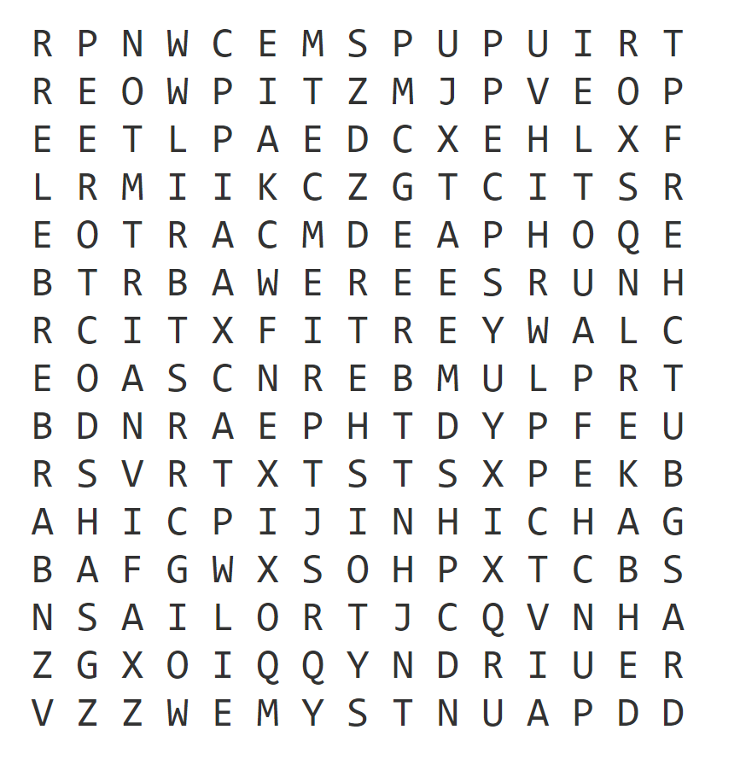

Key:
architect / artist / baker / barber / butcher / chef / dentist / doctor / farmer / lawyer / nurse / pilot / plumber / police / sailor / teacher / veterinarian / waiter

