Name: ____________________________ Surname: ____________________________ N^{ber}: ____ Grade/Class: _____
Assessment: _____________________________ | Date: ___________________________________________________
 | Teacher’s signature:  ___________________________ | Parent’s signature:  ___________________________

Write the following sentences in the question form. Then match the jobs to the correct sentence and add the number in the box.
Example: Tom likes children, he works as a teacher. Does he like children? Is he a teacher?
- 2. 3. 4. 5.
Andy likes to drive, he works as a bus driver. _____________________________________________
Anna loves to dance, she works as a dancer. _____________________________________________
Diana likes restaurants, she works as a waitress. _____________________________________________
Eric loves art he works as an artist. _____________________________________________
Harry wants to help people, he works as a fire fighter. _____________________________________________
James loves animals, he works as a veterinarian. _____________________________________________
Michael likes to read, she works as a writer. _____________________________________________
Tom loves movies, he works as a cameraman. _____________________________________________
Tony likes to cook, he works a chef. _____________________________________________
William loves the sea, he works as a captain on a ship. _____________________________________________

6.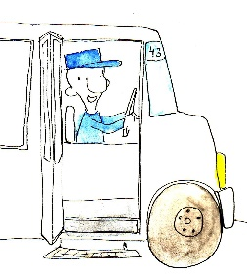 7. 8. 9. 10.

