Name: ____________________________ Surname: ____________________________ N^{ber}: ____ Grade/Class: _____
Assessment: _____________________________ | Date: ___________________________________________________
 | Teacher’s signature:  ___________________________ | Parent’s signature:  ___________________________

Look at the picture and rewrite the sentence in the correct order.

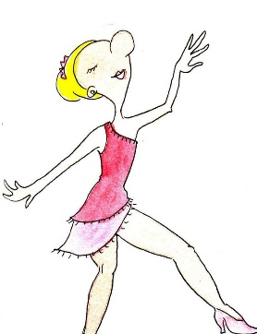
I / move / to / music / the ___________________________________

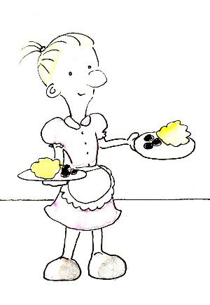

food / serve / I / table / your / to / drinks / and/ ___________________________________

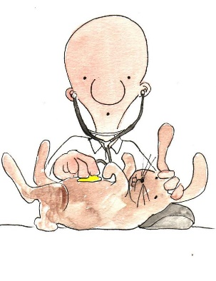

take / I / sick / animals / care / of ___________________________________

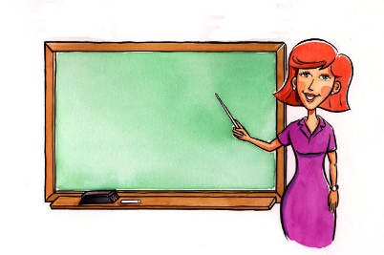

of / in front / I / blackboard / students / use / a ___________________________________

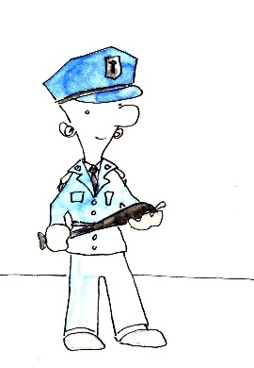

catch / criminals / I / ___________________________________

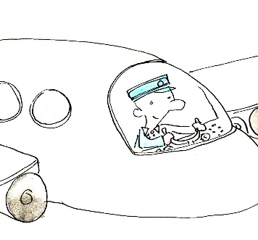
fly / I / airplanes ________________________________

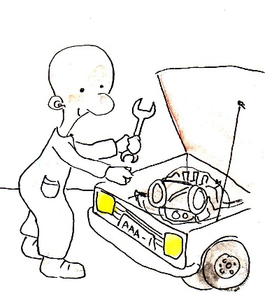

repair / fix / and / I /cars ________________________________

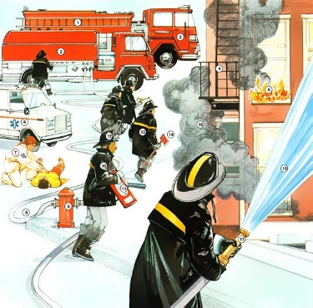

put / I / fires / out / save / people / and _____________________________

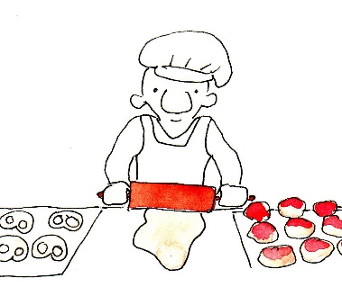

make / I / cakes / breads / and _____________________________

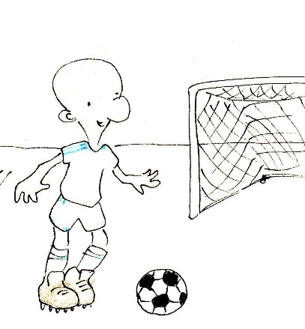

kick / goal / I / a / ball / into _____________________________

