Name: ____________________________ Surname: ____________________________ N^{ber}: ____ Grade/Class: _____
Assessment: _____________________________ | Date: ___________________________________________________
 | Teacher’s signature:  ___________________________ | Parent’s signature:  ___________________________

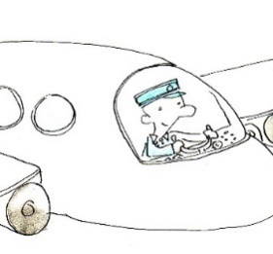
Write the sentence in the correct order and match the jobs to the right sentence.

fly / I / airplanes ________________________________
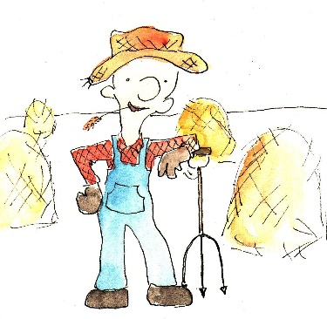

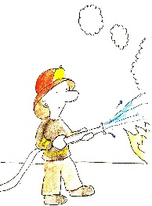
have / chickens / and / I /cows ________________________________

put / I / fires / out / save / people / and _____________________________

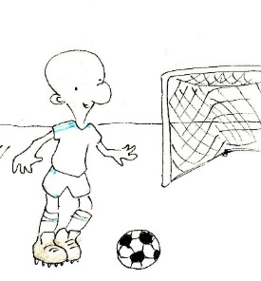

kick / goal / I / a / ball / into _____________________________

