Name: ____________________________ Surname: ____________________________ N^{ber}: ____ Grade/Class: _____
Assessment: _____________________________ | Date: ___________________________________________________
 | Teacher’s signature:  ___________________________ | Parent’s signature:  ___________________________

Write the sentence in the correct order and match the jobs to the right sentence.
I / pancakes / to / like / make / ___________________________________ 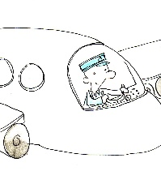
cars / repair / I / broken / ___________________________________
work / I / animals / with / ___________________________________ 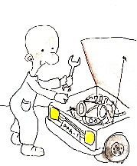
fly / airplane / I / an ___________________________________ 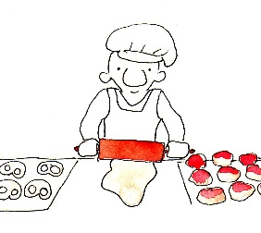
bake / I / and/ bread / cookies ___________________________________

