Name: ____________________________ Surname: ____________________________ N^{ber}: ____ Grade/Class: _____
Assessment: _____________________________ | Date: ___________________________________________________
 | Teacher’s signature:  ___________________________ | Parent’s signature:  ___________________________

Write the sentence in the correct order and match the jobs to the right sentence.
work / in / an / I /office ___________________________________ 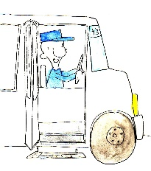
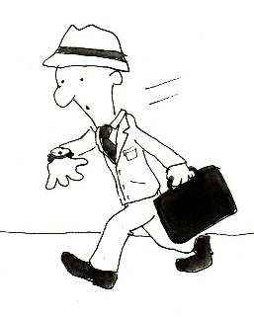
dancing / and / love / I /music ___________________________________

drive / I / bus / a / ___________________________________
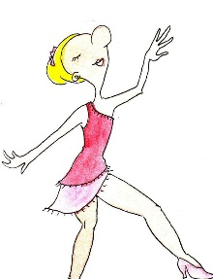

a/ student/ school / am /in / I / a ___________________________________
write / I / books/ stories / and ___________________________________

