Ex 1 A2 My city
Name: ____________________________ Surname: ____________________________ N^{ber}: ____ Grade/Class: _____
Assessment: _____________________________ | Date: ___________________________________________________
 | Teacher’s signature:  ___________________________ | Parent’s signature:  ___________________________
MY TOWN
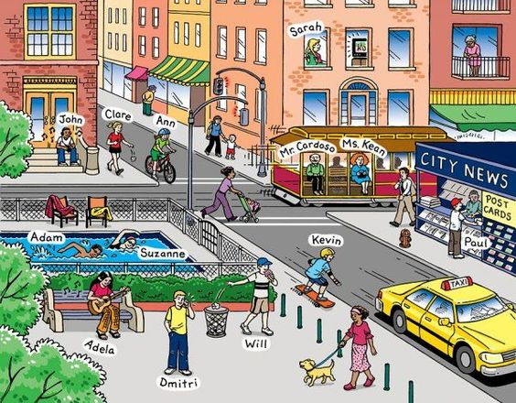

Listen and fill in the missing words.

All people in my town are very busy today! Adela is 1. ------------ on a bench and she is
2. -----------------the guitar. Dimitri is 3. ---------------- to his friend George on his mobile phone. Kevin is 4. ------------------ skateboarding. Ann is 5. ------------- her bike and Adam is 6. ---------------- at the local swimming pool. Mr. Cardoso and Ms. Kean are 7. ----------------- for the bus at the bus station.

Transcript:

All people in my town are very busy today! Adela is 1sitting on a bench and she is 2.playing the guitar. Dimitri is 3.speaking to his friend George on his mobile phone. Kevin is 4.doing skateboarding. Ann is 5.riding her bike and Adam is 6. swimming at the local swimming pool. Mr Cardoso and Ms Kean are 7.waiting for the bus at the bus station.

