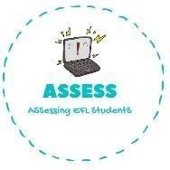
ENGLISH EXAM
Listening

Name: Surname: N^{ber}: Grade/Class:
Assessment: | Date:
 | Teacher’s signature:  _ | Parent’s signature:

1. Listen and match.

8 o’clock
3 o’clock
5 o’clock
8 o’clock
10 o’clock

Assessing EFL Students

