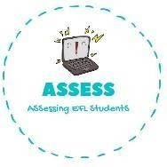
ENGLISH EXAM

Listening

Name: Surname: N^{ber}: Grade/Class:
Assessment: | Date:
 | Teacher’s signature: | Parent’s signature:

1. Listen and complete the dialogue.

Mum: Samantha come on, w _ k _ u_, you must go to s _ h_ _ _. Samantha: Yes mum, I g_ _ d _ e _ s_ _ and h _ _ _ b _ _ a _ _ f _ _. Mum: You must wait your b _ o t _ _ r to come back home.
Samantha: I can’t. I do my h _ _ _ w _ _ _ at school.

Mum: Okay but you must take him to p _ _ y f _ _ t _ a _ _ with his friends. Samantha: Okay I will do it. Bye

Assessing EFL Students

