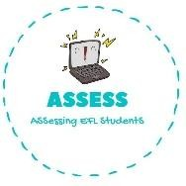
- Listen and order.
Name: Surname: N^{ber}: Grade/Class:
Assessment: | Date:
 | Teacher’s signature:  _ | Parent’s signature:

ENGLISH EXAM

Listening

⚪ ⚪ ⚪ ⚪

- Listen and complete.

Time | Activity
Eight o’ clock in the morning | G_t u_
Twelve o’ clock in the afternoon | H_v_ l_n_h
Four o’ clock in the aternoon | D_ _y h_m_w_r_
Nine o’ clock in the evening | _a_e d_n_e_

Assessing EFL Students

