

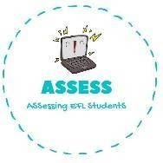1. Listen, match and complete



|  |  |  |
| --- | --- | --- |
| **Name: Surname: Nber: Grade/Class:** | | |
| **Assessment:** | **Date:** | |
| **Teacher’s signature:** | **Parent’s signature:** |

**ENGLISH EXAM**

Listening

MARTHA LUCAS MERY TOM JOHN

· · · · ·

· · · · ·





Get

Go to

Do

Go to the

Have

Assessing EFL Students