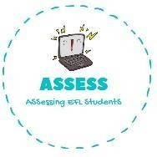
1. Listen and answer the questions.
Name: Surname: N^{ber}: Grade/Class:
Assessment: | Date:
 | Teacher’s signature: | Parent’s signature:

ENGLISH EXAM

Listening

What time is it?

When do you have breakfast?

How do you go to school?

Do you do your homework?

What do you do in your free time?

What Is your favourite meal?

When do you go to sleep?

Assessing EFL Students

