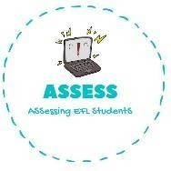
1. Listen, complete and match.
Name: Surname: N^{ber}: Grade/Class:
Assessment: | Date:
 | Teacher’s signature: | Parent’s signature:

ENGLISH EXAM

Listening

H _ _ _ A S _ _ _ _ _

H _ _ _ D _ _ _ _ _

W T _

S _ _ _ _ _ B _ _

H _ _ _ P _ _ _ T _ _ _ _ _

Assessing EFL Students

