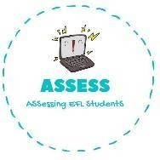
ENGLISH EXAM

Listening

Name: Surname: N^{ber}: Grade/Class:
Assessment: | Date:
 | Teacher’s signature: | Parent’s signature:

1. Listen, colour and complete

The kid is football The school takes you to

You must your everyday

Assessing EFL Students

