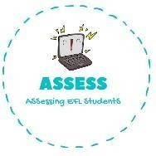
ENGLISH EXAM

Listening

Name: Surname: N^{ber}: Grade/Class:
Assessment: | Date:
 | Teacher’s signature: | Parent’s signature:

1. Listen and complete.

Activity | Time

Have breakfast E _ g _ h t o’ _ _ _ c _ in t_ _ m _ _ n _ _ g

Have lunch O _ _ o’ _ _ o _ _ in t _ _ a _ _ _ r _ _ o _

Do my homework F _ u _ o’c _ _ _ _ in the a _ _ _ _ _ _ _ _

Play football S _ v _ _ o’_ _ _ _ _ in the e _ _ n _ _ _

Have dinner N _ _ _ o’ _ _ _ _ _ in the e _ _ _ _ _ _

Go to sleep T _ n o’ c _ _ _ _ at n _ _ _ _

Assessing EFL Students

