Exercise 1 A1 My city/town
Name: ____________________________ Surname: ____________________________ N^{ber}: ____ Grade/Class: _____
Assessment: _____________________________ | Date: ___________________________________________________
 | Teacher’s signature:  ___________________________ | Parent’s signature:  ___________________________

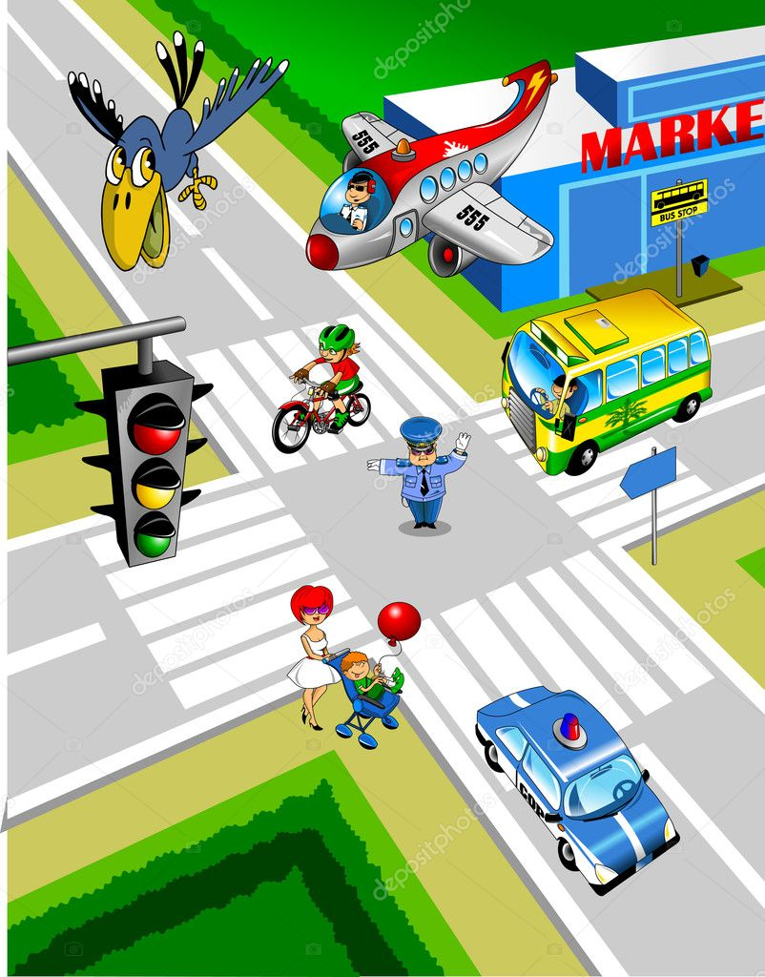
Look at this photo and write YES or NO
Example: There is a bird in the air YES There is a train in the photo NO
- There are two airplanes in the photo ………..
- There is one policeman in the street ………..
- There is one red bus in the street ………..
- There is a set of traffic lights ………..
- There is a police car in the photo ………..
- There is a bike in the street ………..
- There is a supermarket at the corner of the road ………..
- There is a café in the photo ………..

Key: 1.No 2. Yes 3. No 4. Yes 5. Yes 6. Yes 7. Yes 8. No

