Ex. 3 A1 my city
Name: ____________________________ Surname: ____________________________ N^{ber}: ____ Grade/Class: _____
Assessment: _____________________________ | Date: ___________________________________________________
 | Teacher’s signature:  ___________________________ | Parent’s signature:  ___________________________

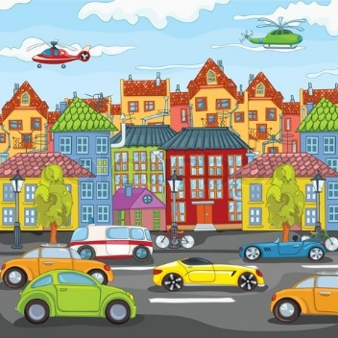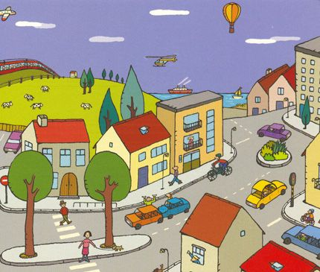

Write 5 things that there is/ are in your town/city e.g a park

- ----------------------------------------------------
- ----------------------------------------------------
- ----------------------------------------------------
- ----------------------------------------------------
- -----------------------------------------------------

