Ex 4 A1 my city
Name: ____________________________ Surname: ____________________________ N^{ber}: ____ Grade/Class: _____
Assessment: _____________________________ | Date: ___________________________________________________
 | Teacher’s signature:  ___________________________ | Parent’s signature:  ___________________________

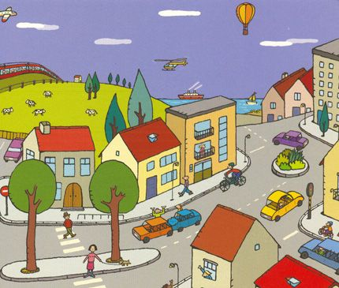
Match the following words with the places in a town.
cars/ students/ nurses/ airplanes/ trains/ / trees /aspirins

1. Hospital ------------------
2. School ------------------
3. Airport ------------------
4. Park …………….......
5. Pharmacy -----------------
6. Road ------------------
7. Train station -------------------

