Ex. 5 A2 my city
Name: ____________________________ Surname: ____________________________ N^{ber}: ____ Grade/Class: _____
Assessment: _____________________________ | Date: ___________________________________________________
 | Teacher’s signature:  ___________________________ | Parent’s signature:  ___________________________

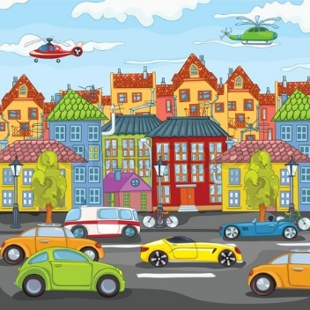

Write a small paragraph describing your town/city by including these words:

Road(s) / school (s) / park(s)/ cinema(s)/ hospital(s)/ shopping mall(s) / shop(s)

