Exercise 5 A1 The place I live – my town
Name: ____________________________ Surname: ____________________________ N^{ber}: ____ Grade/Class: _____
Assessment: _____________________________ | Date: ___________________________________________________
 | Teacher’s signature:  ___________________________ | Parent’s signature:  ___________________________
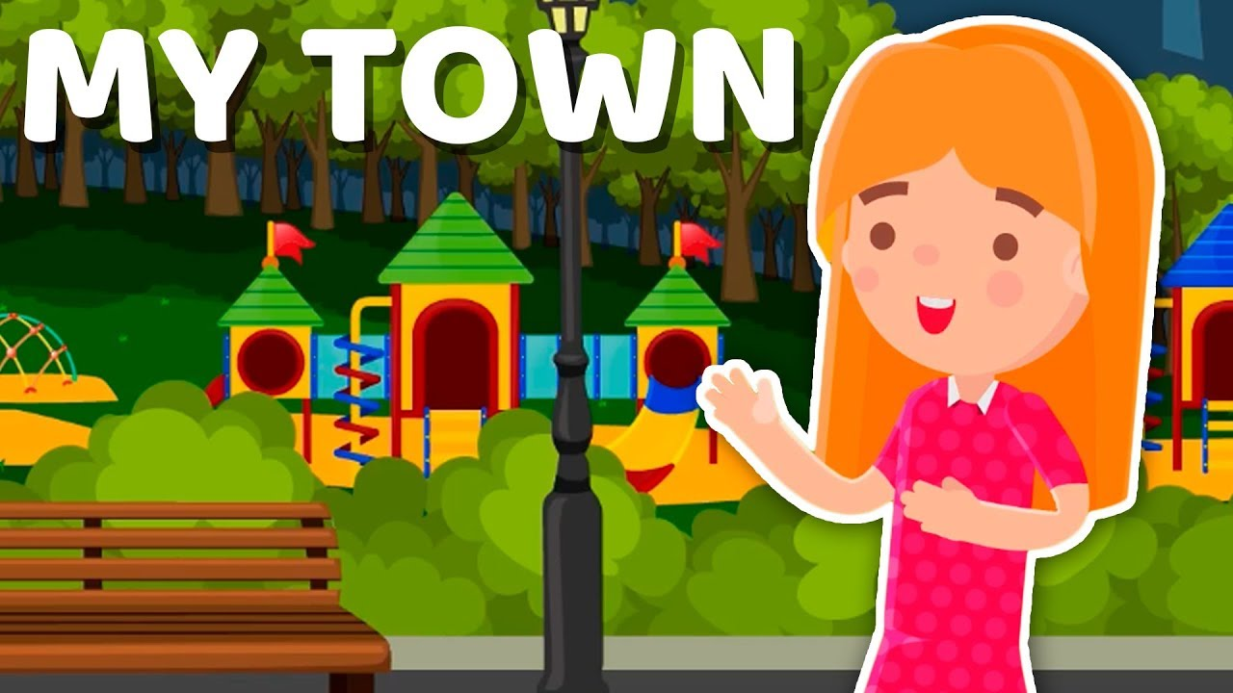

My Town
Christina lives in a big town. In her town, there are many shops. There is a florist’s, a shoe shop, a bakery, a pharmacy, a toy shop, a pet shop and a supermarket.
She goes to the pet shop every Saturday because she likes to look at the parrots, the puppies and the mice. The pet shop is between the supermarket and the pharmacy. Then she goes to the park to see her friends.

TRUE OR FALSE?
- Christina’s town is small --------------
- In Christina’s town, there is a shoe shop --------------
- Christina’s favourite shop is the shoe shop --------------
- She visits the pet shop every Sunday --------------
- The pet shop is opposite the supermarket --------------

Key: 1. False 2. True 3. False 4. False 5. False

