E. 2 A1 My city
Name: ____________________________ Surname: ____________________________ N^{ber}: ____ Grade/Class: _____
Assessment: _____________________________ | Date: ___________________________________________________
 | Teacher’s signature:  ___________________________ | Parent’s signature:  ___________________________

My lovely little Town
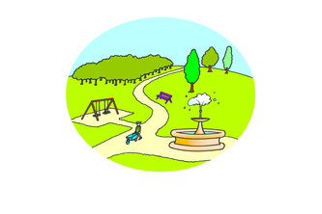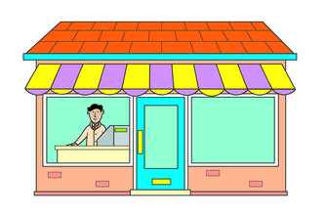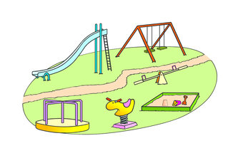

In my town, there is a playground, a shopping centre with a lot of different shops, a train station, a supermarket and a cinema.
There is also a park, a factory, a library and 3 schools.

Answer the questions with YES or NO

- There are 4 schools in my town _________
- There are 2 supermarkets in my town _________
- There is a park in my town _________
- There is a library in my town _________

