Ex. 3 A1 my city
Name: ____________________________ Surname: ____________________________ N^{ber}: ____ Grade/Class: _____
Assessment: _____________________________ | Date: ___________________________________________________
 | Teacher’s signature:  ___________________________ | Parent’s signature:  ___________________________

Read the passage and fill in the missing words.

The place I live
In my town, there is a _______________ 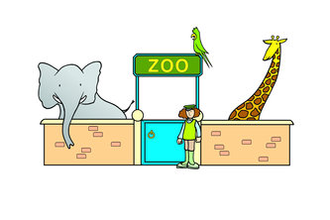,
There are a lot of ----------------------------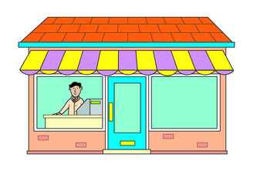, a train station, a supermarket and a cinema.
There is a -----------------------, a factory, a library and 2 schools.

In my town, there is a playground, a shopping centre with a lot of different shops, a train station, a supermarket and a cinema.
There is also a park, a factory, a library and 3 schools.

