Ex. 4 A1 my city
Name: ____________________________ Surname: ____________________________ N^{ber}: ____ Grade/Class: _____
Assessment: _____________________________ | Date: ___________________________________________________
 | Teacher’s signature:  ___________________________ | Parent’s signature:  ___________________________

My city
Read the sentences and fill in the missing words

I live in a big city which is full of noise with a lot of ___________________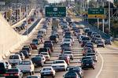
and many _________________________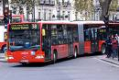
The streets are full of_________________________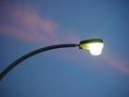
Unfortunately, we don’t have a --------------------------------------

