Name: ____________________________ Surname: ____________________________ N^{ber}: ____ Grade/Class: _____
Assessment: _____________________________ | Date: ___________________________________________________
 | Teacher’s signature:  ___________________________ | Parent’s signature:  ___________________________

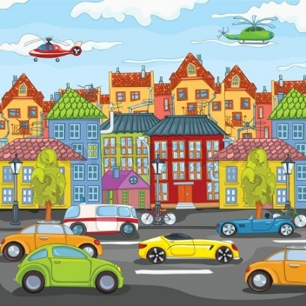

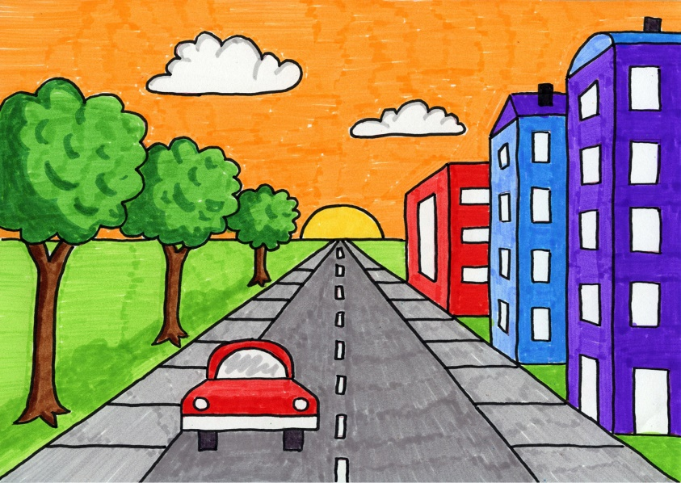

Can you tell me some differences you can see in these two photos?
For example, there are a lot of buildings in the first photo while there are only 3 buildings in the second photo

