Ex A1 my city
Name: ____________________________ Surname: ____________________________ N^{ber}: ____ Grade/Class: _____
Assessment: _____________________________ | Date: ___________________________________________________
 | Teacher’s signature:  ___________________________ | Parent’s signature:  ___________________________

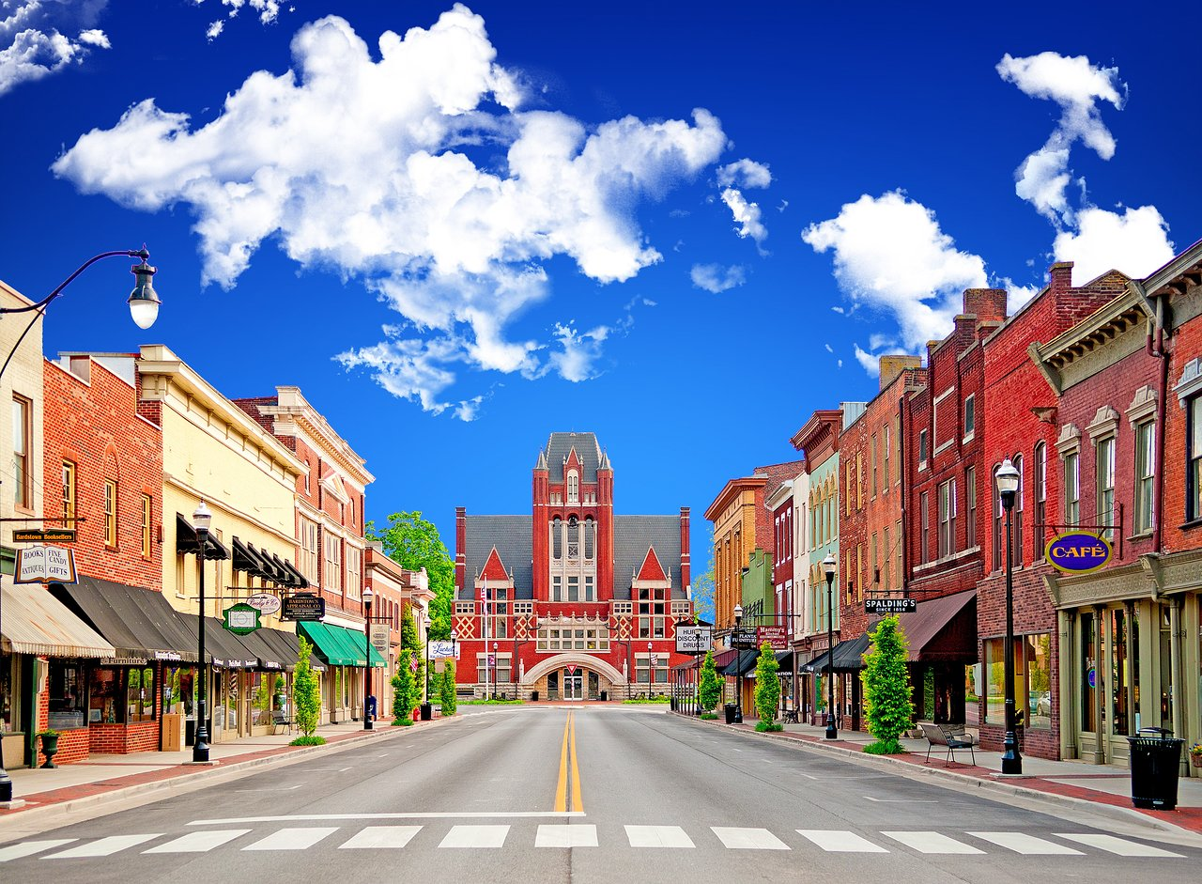

This is a beautiful town with big roads and lovely buildings.

Does your city/town look the same or different?

What is the same and what is different in your city/town?

