Ex A1 my city
Name: ____________________________ Surname: ____________________________ N^{ber}: ____ Grade/Class: _____
Assessment: _____________________________ | Date: ___________________________________________________
 | Teacher’s signature:  ___________________________ | Parent’s signature:  ___________________________

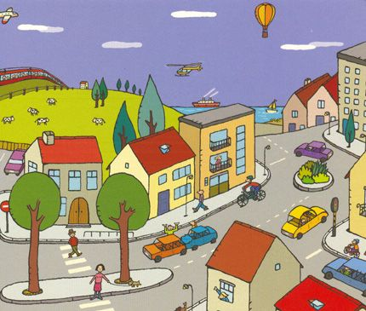

I would like you to have a look at this picture and then to answer my questions.

Do you like this small town? (Why/ Why not?)
Is there a school in this town?
How many cars can you see on the road?
Now, tell me something about your town. Is it a big /small town? Are there any shops in your town?

