Ex. 1 A1 My city
Name: ____________________________ Surname: ____________________________ N^{ber}: ____ Grade/Class: _____
Assessment: _____________________________ | Date: ___________________________________________________
 | Teacher’s signature:  ___________________________ | Parent’s signature:  ___________________________

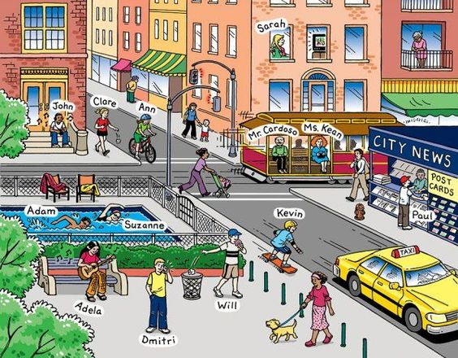

Unscramble these letters and write the correct word:

- KRPA ____________
- TERETS ____________
- YRALIBR ____________
- YREKBA ____________
- LOHOCS _____________

KEY
1. PARK
2. STREET
3. LIBRARY
4. BAKERY
5. SCHOOL

