Ex. 4 A1 My city
Name: ____________________________ Surname: ____________________________ N^{ber}: ____ Grade/Class: _____
Assessment: _____________________________ | Date: ___________________________________________________
 | Teacher’s signature:  ___________________________ | Parent’s signature:  ___________________________

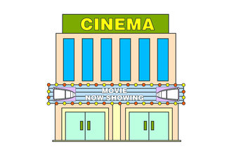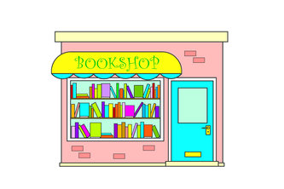

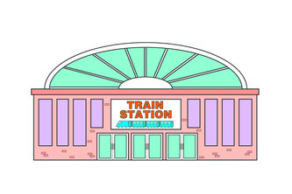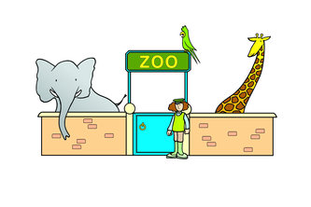

- Are there these 4 places in your town /city? YES /NO

- Which of these places/shops do you like the most? ________________

- Write five (5) more shops or places that there are in your town/city :
________________________________________________________________
________________________________________________________________
________________________________________________________________

