Exercise 5 A1 The place I live in – my city
Name: ____________________________ Surname: ____________________________ N^{ber}: ____ Grade/Class: _____
Assessment: _____________________________ | Date: ___________________________________________________
 | Teacher’s signature:  ___________________________ | Parent’s signature:  ___________________________

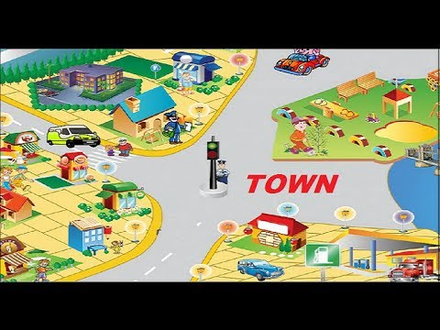

Match the following words with the places in a town.

Car/ pupil/ doctor/ airplane/ train/ shops/ playground

- Hospital ------------------
- School ------------------
- Airport ------------------
- Park …………….......
- Shopping mall -----------------
- Road ------------------
- Train station -------------------

