EX. 2 A2 my city
Name: ____________________________ Surname: ____________________________ N^{ber}: ____ Grade/Class: _____
Assessment: _____________________________ | Date: ___________________________________________________
 | Teacher’s signature:  ___________________________ | Parent’s signature:  ___________________________

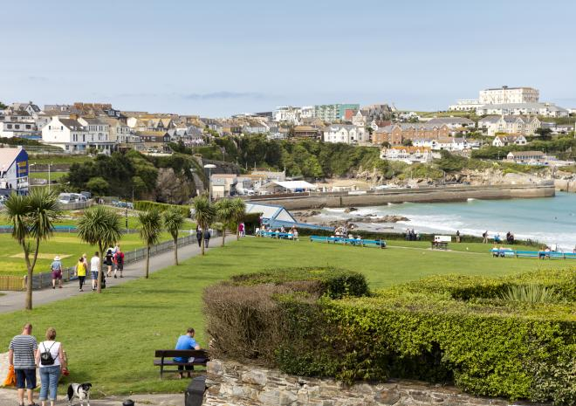

My town Newquay
I love Newquay because there are lots of other things you can do there like surfing and scuba diving. If you like water sports, you can go kayaking and water-skiing as well.
If you like animals you can also visit the Aquarium and see lots of different fish and even sharks. You can also go horse riding on the beach or visit Newquay Zoo. There are lots of other attractions too like mini golf and bowling. Come and see for yourself!
Answer the following questions by putting √ or X
- The weather in Newquay. -----
- Places to visit in Newquay. -----
- Things to do in Newquay. -----
- History of Newquay. ------

