Ex. 3 A2 my city
Name: ____________________________ Surname: ____________________________ N^{ber}: ____ Grade/Class: _____
Assessment: _____________________________ | Date: ___________________________________________________
 | Teacher’s signature:  ___________________________ | Parent’s signature:  ___________________________

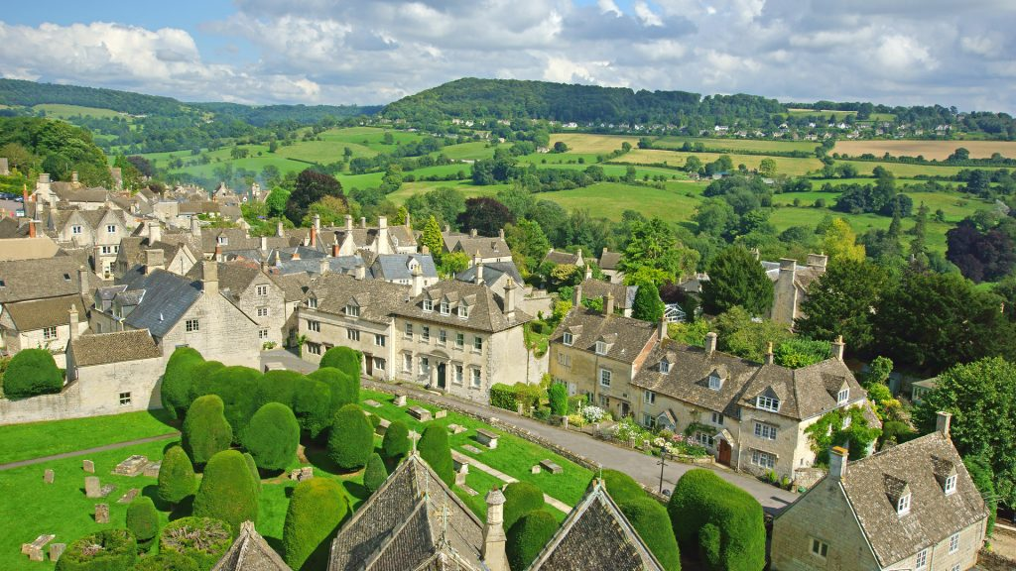

Read the passage and match the questions with the correct answer.
My village
I live in Clarington, which is a village on south of England. My village is 19 km from Taunton. It has a population of 1500 people. Clarington is one of the fourteen villages of Taunton.
It's a small village with a beautiful view on the mountains. It is the best place for relaxation. You can listen the voice of birds or look at the beautiful forests. It is very good place to ride a bike or go swimming in the river called Vestron. There is a museum, two churches and several shops.

- Where is Clarington? A. 14
- What can you do in Clarington? B. 1500
- How many villages are there in Taunton? C. On south of England
- How many people live in Clarington? D. Riding a bike, swimming in the river.

