Ex. 5 A2 my city/town
Name: ____________________________ Surname: ____________________________ N^{ber}: ____ Grade/Class: _____
Assessment: _____________________________ | Date: ___________________________________________________
 | Teacher’s signature:  ___________________________ | Parent’s signature:  ___________________________

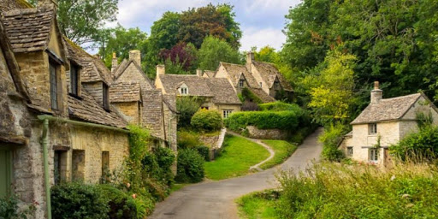

Why I like my village
I think that the best thing about my village is the silence and nice atmosphere.
My village is very safe and friendly. People help each other a lot. It is a small place and you know everybody. There is clean air, pretty views, that's the reasons why I like living here.

Answer the following questions:
- What is the best thing about this village? ________________
- Is the village safe to live there? _________________
- Are the people friendly and helpful? _________________

