Exercise 1 A2 The place where I live – my city
Name: ____________________________ Surname: ____________________________ N^{ber}: ____ Grade/Class: _____
Assessment: _____________________________ | Date: ___________________________________________________
 | Teacher’s signature:  ___________________________ | Parent’s signature:  ___________________________

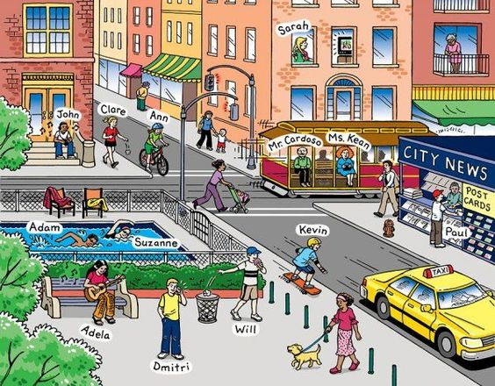
Look at the photo of the town and say what is happening.
e.g. Adela is playing the guitar What are the others doing?

How many cars are in the photo?
How many people are swimming in the pool?
How many dogs are there in the photo?

