Ex A2 Speaking
Name: ____________________________ Surname: ____________________________ N^{ber}: ____ Grade/Class: _____
Assessment: _____________________________ | Date: ___________________________________________________
 | Teacher’s signature:  ___________________________ | Parent’s signature:  ___________________________

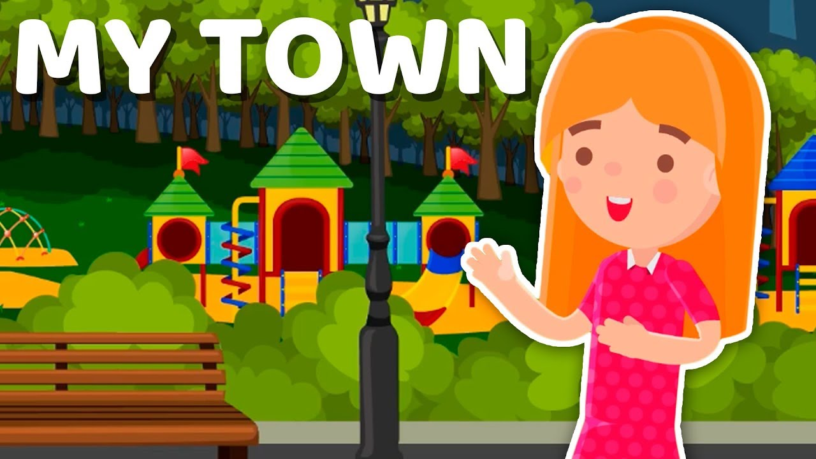

This is Christina’s little town and she likes it very much!

She likes it because it is quiet without many cars but there isn’t a shopping mall in her town and she doesn’t like this.

What do you like and what don’t you like about your town/city?

