Exercise A2 The place where I live – My city
Name: ____________________________ Surname: ____________________________ N^{ber}: ____ Grade/Class: _____
Assessment: _____________________________ | Date: ___________________________________________________
 | Teacher’s signature:  ___________________________ | Parent’s signature:  ___________________________
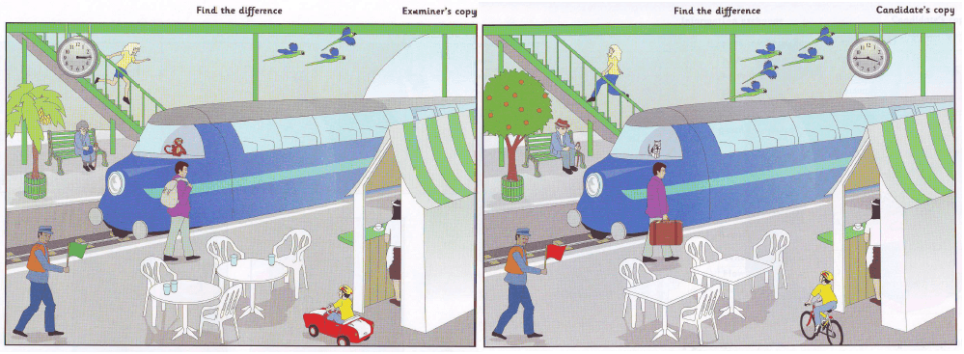
Now here are two pictures. My picture is nearly the same as yours, but some things are different.
For example, in my picture there are three birds, but in your picture there are five. OK?

I am going to say something about my picture.

In my picture, a girl is running down the stairs.
In my picture, the man with a purple jacket has got a rucksack
In my picture, there are four glasses on the tables

You tell me how your picture is different.

