Exercise 1 A2 My city/town
Name: ____________________________ Surname: ____________________________ N^{ber}: ____ Grade/Class: _____
Assessment: _____________________________ | Date: ___________________________________________________
 | Teacher’s signature:  ___________________________ | Parent’s signature:  ___________________________
Match the following words with the correct photo:
Playground / Road / Traffic lights /Bus /Park
a. ------------------- 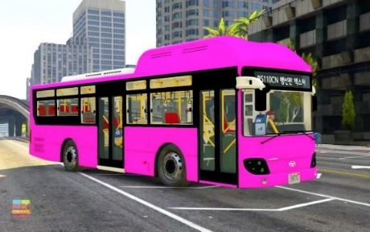 b. --------------------- c. ---------------------- 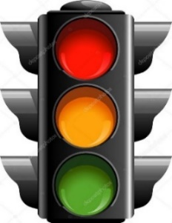 d.-----------------------

e.--------------------------- 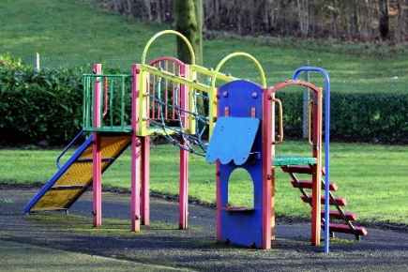

Key: a. bus b. park c. traffic lights d. road e. playground

