EX 2 A2 My city
Name: ____________________________ Surname: ____________________________ N^{ber}: ____ Grade/Class: _____
Assessment: _____________________________ | Date: ___________________________________________________
 | Teacher’s signature:  ___________________________ | Parent’s signature:  ___________________________

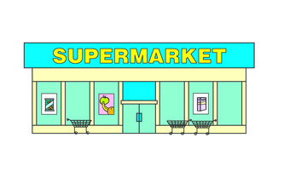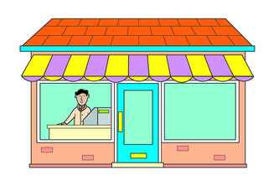
My City
Georgia lives in a big city. There are so many people and so much noise in this city. There are many shops. There are three florists, five shoe shops, bakeries, pharmacies, toy shops, pet shops, two libraries and a 5 big supermarkets.
She goes to the local pet shop every Saturday because she likes to look at the parrots, the puppies and the kittens. The pet shop is opposite the supermarket. Then she goes to the bakery to get some bread. After that she meets her friends at the park.
TRUE OR FALSE?
1. Christina’s lives in a small city -------------
2. In Christina’s city, there are no shoe shops --------------
3. Christina’s favourite shop is the pet shop --------------
4. She visits the pet shop every Sunday --------------
5. The pet shop is opposite the pharmacy --------------

Write the names of the shops that there are in Georgia’s city:
______________________________________________________________________________________________________________________________________________________

