Ex.4 A2 My city
Name: ____________________________ Surname: ____________________________ N^{ber}: ____ Grade/Class: _____
Assessment: _____________________________ | Date: ___________________________________________________
 | Teacher’s signature:  ___________________________ | Parent’s signature:  ___________________________

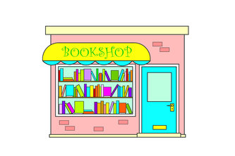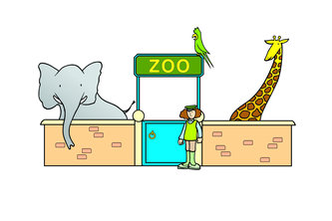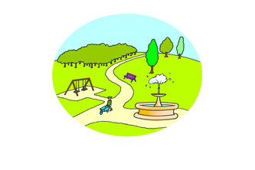

Match the following group of words with the places where you can find these things:

- Apples, oranges, vegetables A. Library
- Monkeys, giraffes, tigers B. Pharmacy
- Books, magazines C. Zoo
- Pills, aspirins, medicines D. Greengrocer’s
- Cars, lorries, bicycles E. Park
- Playground, swings, slides F. Streets

