TOPIC: My City | SUBTOPICS: Vocabulary- speaking(discussion) | LEVEL: A1
Name: ____________________________ Surname: ____________________________ N^{ber}: ____ Grade/Class: _____

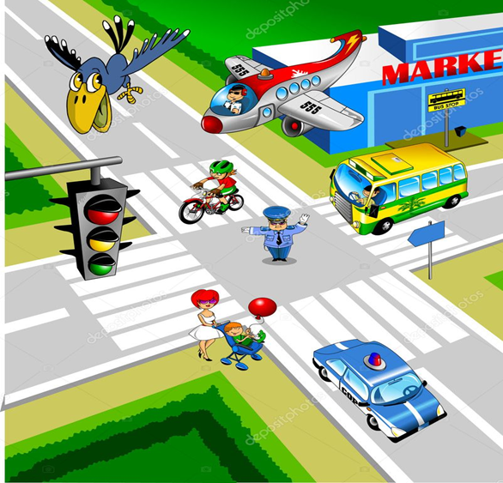

Look at this photo and put a tick √ or X next to the sentences describing the above photo.

Example: There is a bird in the air √ There is a train in the photo X

1. There is one airplane in the photo --------
2. There are two policemen in the street ………..
3. There is one yellow bus in the street ………..
4. There is a set of traffic lights ………..
5. There is a police car in the photo ………..
6. There are two bikes in the street ………..
7. There is a supermarket at the corner of the road ………..
8. There is a café in the photo ………..
9. There is a mum with her baby in the street _____
10. There are two red cars in the street. _____

KEY: tick 1, 3, 4, 5 , 7, 9

Speaking: (Discussion)

Now, can you tell me what is/are there in your city/town?

e.g. Is there a supermarket? Are there any other shops Is there a park?

