Ex. 1 A1 The place where I live – my city
Name: ____________________________ Surname: ____________________________ N^{ber}: ____ Grade/Class: _____
Assessment: _____________________________ | Date: ___________________________________________________
 | Teacher’s signature:  ___________________________ | Parent’s signature:  ___________________________

Listen and colour

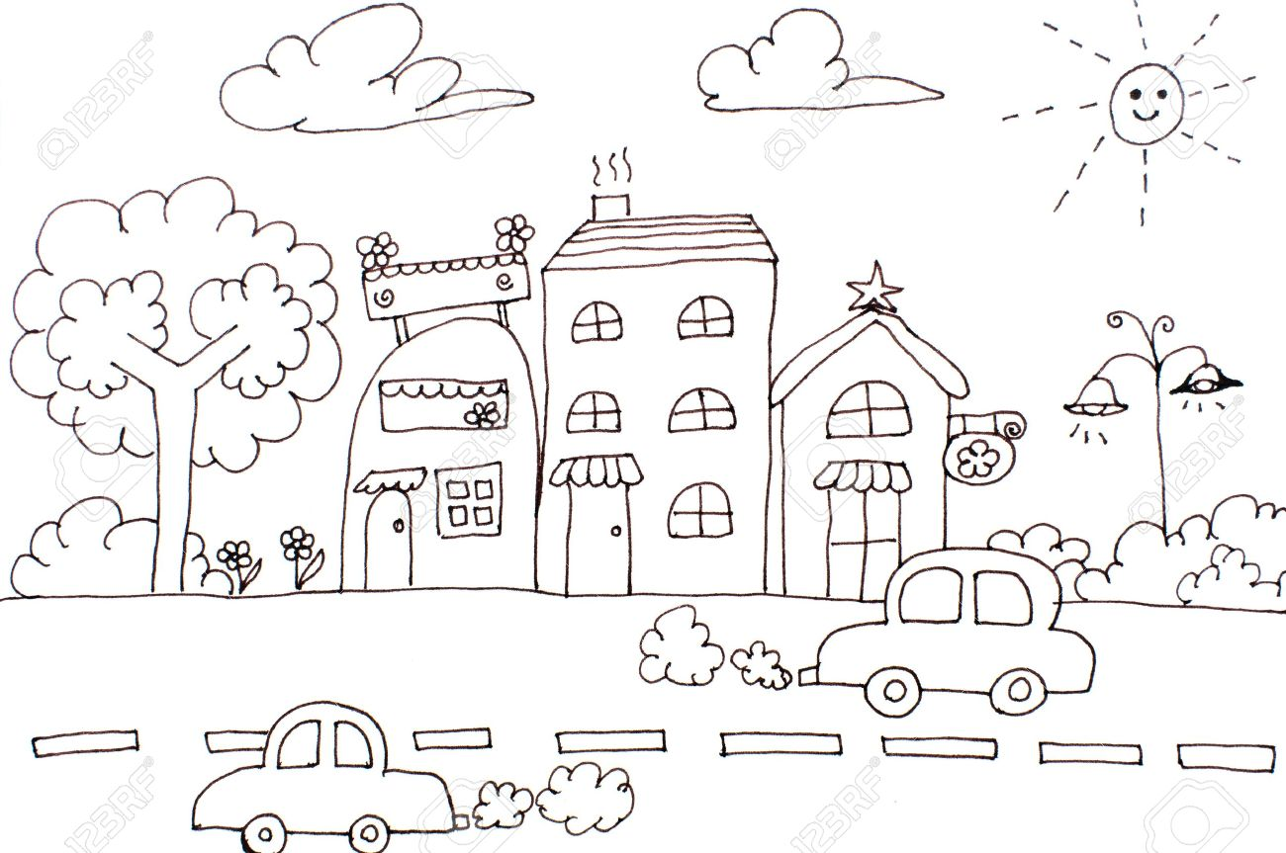

Key: Draw red the cars, black the clouds, green the tree and brown the houses.

Transcript:
I live in a beautiful, big city with lots of roads and parks.
In this photo of my town, there are two red cars and two black clouds because it is going to rain soon.
There is also a tall, green tree and three brown houses. I like my town very, very much!!

