Ex 2 A1 My city
Name: ____________________________ Surname: ____________________________ N^{ber}: ____ Grade/Class: _____
Assessment: _____________________________ | Date: ___________________________________________________
 | Teacher’s signature:  ___________________________ | Parent’s signature:  ___________________________

Listen and fill in the gaps with the missing word.

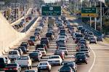 The roads are full of -------------- in the morning
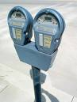 There are many parking ------------ in my city
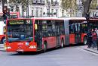 I love the ------------! They are big and red! Many people use them.

Transcript:

My city is very noisy!
The roads are full of cars in the morning but they are empty at night.
There are many parking areas in my city to park your car.
I love the buses! They are big and red! Many people use them.

