Ex. 4 A1 The place I live
Name: ____________________________ Surname: ____________________________ N^{ber}: ____ Grade/Class: _____
Assessment: _____________________________ | Date: ___________________________________________________
 | Teacher’s signature:  ___________________________ | Parent’s signature:  ___________________________

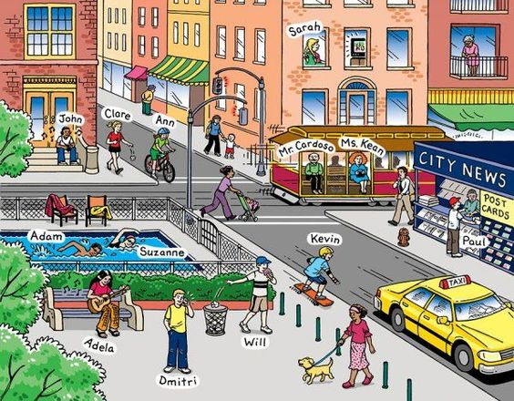
Listen and fill in the missing letters in the following city words.
- S _ R _ _ T
- T _ X _
- H _ _ S _
- P _ R _
- S _ _ P
- T _ A _ F I _ L _G _ T _
- P _ V _ M _ _ T

Transcript :
Spell out the following words :
1. S T R E E T
2. T A X I
3. H O U S E
4. P A R K
5. S H O P
6. T R A F F I C L I G H T S
7. P A V E M E N T

