TOPIC: My city | SUBTOPICS: Vocabulary- places in a city | LEVEL: A1
Name: ____________________________ Surname: ____________________________ N^{ber}: ____ Grade/Class: _____

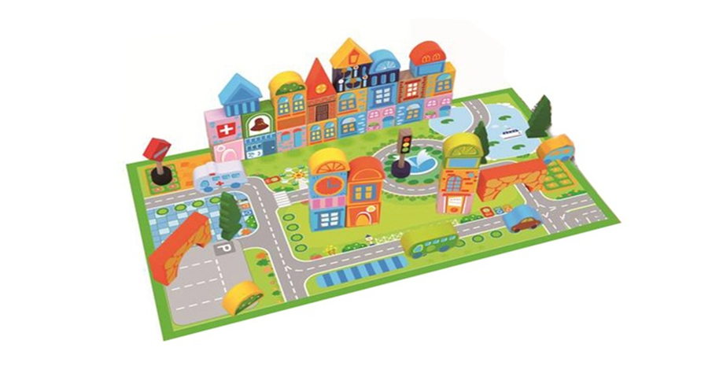
Fill in the gaps with the words from the box below :
There are a lot of things you can see in a big city!! There are so many 1.________ in the streets full of people.
You can find playgrounds for your children to play at the 2.______ and finally there are3. _______where you can buy anything you want from clothes to electronic gadgets at the modern shopping 4._______ .
park busses shops mall

Key: 1 busses 2 park 3 shops 4 mall

Are there these buildings and areas in the place where you live? Put a √ or X next to them.
1.Car park ----------------
2.Post Office ---------------
3.Petrol Station ---------------
4.Bus Station ----------------
5.Hospital -----------------

