Ex 5 A1 My city
Name: ____________________________ Surname: ____________________________ N^{ber}: ____ Grade/Class: _____
Assessment: _____________________________ | Date: ___________________________________________________
 | Teacher’s signature:  ___________________________ | Parent’s signature:  ___________________________

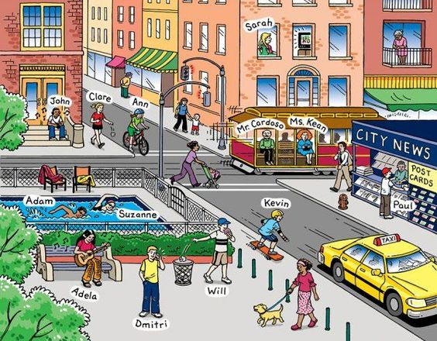
Put the letters in the correct order to form words that are about a town/city
- Posh ---------------------------
- Doar ----------------------------
- Ntiar -----------------------------
- Xiat ----------------------------
- Sbu ----------------------------
- Kpra ---------------------------
- Féac ----------------------------

Key:
1. Shop
2. Road
3. Train
4. Taxi
5. Bus
6. Park
7. Café

