Exercise 1 A1 the place where I live - My city/town
Name: ____________________________ Surname: ____________________________ N^{ber}: ____ Grade/Class: _____
Assessment: _____________________________ | Date: ___________________________________________________
 | Teacher’s signature:  ___________________________ | Parent’s signature:  ___________________________

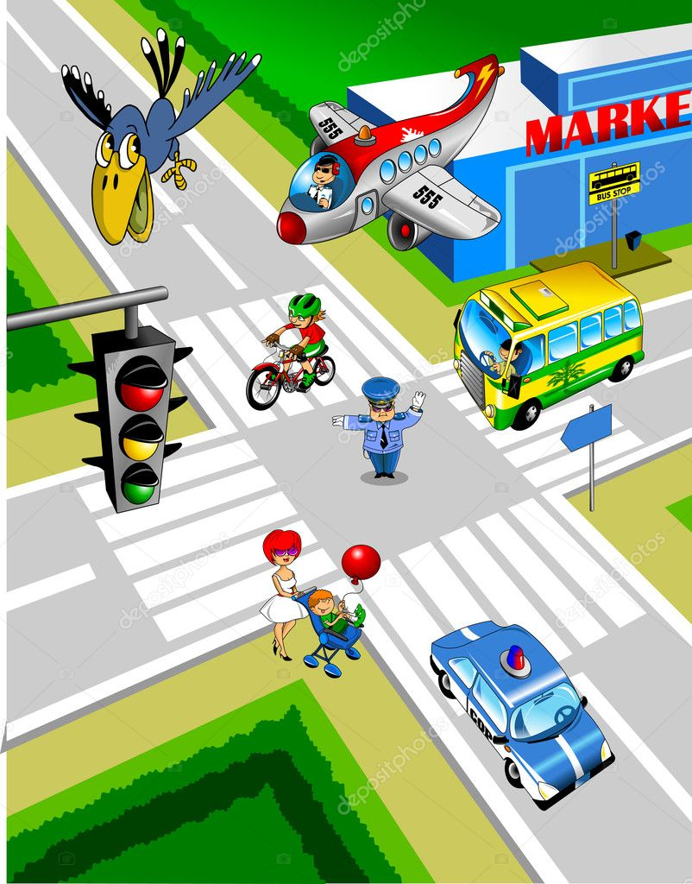
Look at this photo and write YES or NO
Example: There is a bird in the air YES There is a train in the photo NO
- There are two airplanes in the photo --------
- There is one policeman in the street ………..
- There is one red bus in the street ………..
- There is a set of traffic lights ………..
- There is a police car in the photo ………..
- There is a bike in the street ………..
- There is a supermarket at the corner of the road ………..
- There is a café in the photo ………..

RUBRICS total 16 marks

Task Achievement - Two points for each correct answer given (16 Marks)
Excellent: 12-16
🙂👏
Very Good: 8-11
🙂
Satisfactory: 4-7
😐
Unsatisfactory: 2-3
☹️
Poor: 0-1
☹️

Key: 1.No 2. Yes 3. No 4. Yes 5. Yes 6. Yes 7. Yes 8. No

