Name: ____________________________ Surname: ____________________________ N^{ber}: ____ Grade/Class: _____
Assessment: _____________________________ | Date: ___________________________________________________
 | Teacher’s signature:  ___________________________ | Parent’s signature:  ___________________________

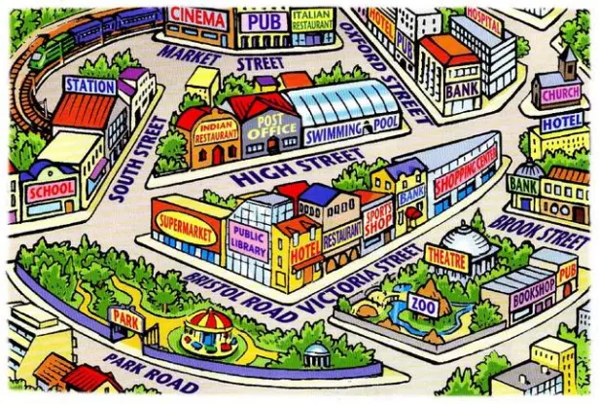
This is my town and I like it very much.
Answer the following questions with YES or NO
1.There is a cinema in my town ---------- 2.There are two theatres in my town----------------
3.There is a school in my town------------------------ 4. There is a swimming pool in my town
5.There is a lake in my town---------------------------

Marking scheme total 10 marks

Task Achievement - Two points for each correct answer given (10 Marks)
Excellent: 9-10
🙂👏
Very Good: 7-8
🙂
Satisfactory: 5-6
😐
Unsatisfactory: 3-4
☹️
Poor: 0-2
☹️

Key:
1 YES 2 NO 3 YES 4.YES 5.NO

