Ex. 3 A1 my city
Name: ____________________________ Surname: ____________________________ N^{ber}: ____ Grade/Class: _____
Assessment: _____________________________ | Date: ___________________________________________________
 | Teacher’s signature:  ___________________________ | Parent’s signature:  ___________________________

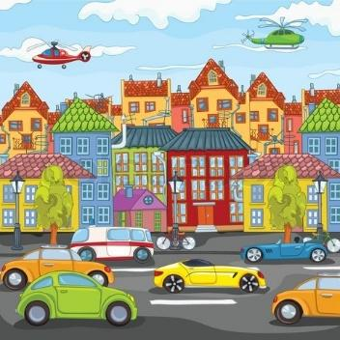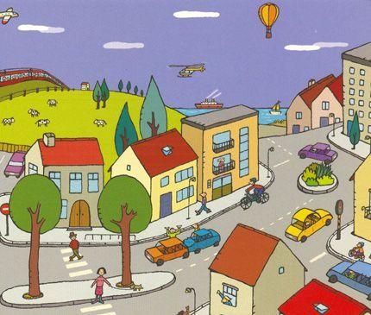

Write 5 things that there is/ are in your town/city e.g. a park

- ----------------------------------------------------
- ----------------------------------------------------
- ----------------------------------------------------
- ----------------------------------------------------
- -----------------------------------------------------

Marking Scheme
Task Achievement - Two points for each correct answer given (10 Marks)
Excellent: 8-10 80-100%
Very Good: 5-7 50- 70%
Satisfactory: 4-6 40- 60%
In need of improvement: 1-3 10- 30%

KEY
CAR/CARS/ HOUSE/ HOUSES TREE/ TREES ROAD/ ROADS PEOPLE BUS/BUSES ETC.

